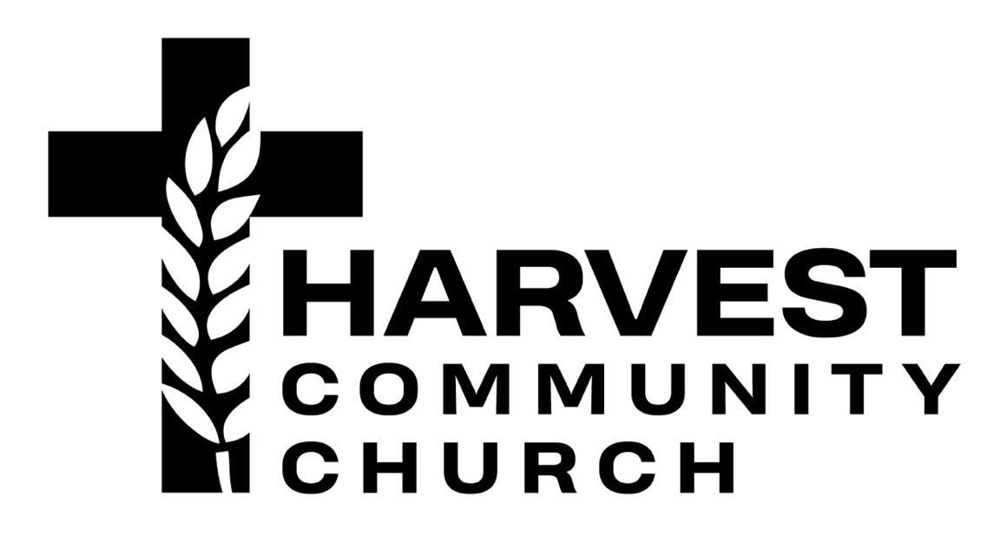

Worship + Young Adults Director [full-time]

Harvest Community Church of Irvine is a multicultural church in Southern California seeking a high-character leader and shepherd for the new role of Worship + Young Adults Director.

The Worship + Young Adults Director’s primary role is to develop and lead a reproducible Christ-centered worship and young adult culture at Harvest Community Church. The Worship Director will shepherd the Body of Christ in worship and oversee the health and development of the worship ministry.

The Worship + Young Adults Director will also develop and lead our ministry and investment in young adults at Harvest Community Church. The Young Adults Director will personally shepherd the young adults at Harvest by discipling them toward maturity in Christ and integrating them into the life of the larger church body.

Personal leadership qualities characterized by Christlike:
- Shepherding/discipleship
- Humility
- Relational/interpersonal skills
- Vision casting

Worship Director Responsibilities [approx. 80%]
- Develop, manage, train, and lead worship teams for Sunday worship service.
- Build, oversee, and shepherd Harvest’s worship ministry, incl: recruit/train volunteer worship leaders and creative ministry team.
- Champion and support a culture of worship that places emphasis on raising up the next generation.
- Strengths, Gifts, Experience in:
- Orchestration/understanding across worship service/instruments
- Musical proficiency with instruments and vocals
- Ministry training and development (equipping)
- Planning and organization

Young Adults Director Responsibilities [approx. 20%]
- Connect with Harvest young adults; lead a weekly ministry; facilitate Bible study.
- Develop structure for young adults to be discipled and grow in faith and community.
- Strengths, Gifts, Experience in:
- Discipleship, shepherding, and community building
- Ability to form and lead a young adult community

Harvest Leadership Responsibilities
- A committed follower of Jesus Christ, relying on the Bible as the foundation and standard for understanding what that means.
- Understanding of and willingness to serve within the doctrinal commitments of the church
- A sense of calling toward ministry and a lifestyle congruent with the biblical requirements for leaders (1 Timothy 3:1-13; 2 Timothy 2; Titus 1:5-9)
About Harvest…
- Church size: 100-150
- Denominations: Non-denominational
- Multicultural
- Welcome to Harvest…

Role Details / Requirements
- Full-time; salary
- Reports to Lead Pastor
- Education / Experience
  - Undergraduate degree, required (in related field, preferred)
  - MDiv or MA in Theology, optional
  - 2+ years of ministry experience, preferably leading a worship/related ministry
- Benefits / Career Development / Educational Assistance
- Training and development toward growth in ministry/role/ordination as this position grows through God’s leading, unique giftings, and ministry career
- On-site / Hybrid

Provide: Resume; cover letter sharing your heart; references; links to videos of you leading worship or music outside of worship to: alfred@harvestirvine.org

