PROFILE OF THE FIRST CONGREGATIONAL CHURCH OF PERU ILLINOIS

May 13, 2021
First Congregational Church of Peru
1431 Fourth St.
Peru, IL 61354 Web page: www.firstcongregationalperu.net
Telephone: (815) 223-0722 Contact E-Mail: firstcongregationalperu@yahoo.com

The purpose of this church shall be to bind together in fellowship followers of Jesus Christ to share in the worship of God and in making His will dominant in the lives of persons individually and collectively, as that will is set forth in the life, teachings, death and living presence of Jesus Christ. This church shall seek to build in children, young people, and adults, strong Christian character and conviction, anxious and unafraid to express itself in the daily life of this world.

SEARCH COMMITTEE INFORMATION

Name of Chairman: Dean Tieman
1237 Tonti St.
La Salle IL 61301
Cell: (815) 228-0353

Name of Vice Chairman Ellen Marincic
2621 E. 494th Rd
Oglesby, IL 61348
Cell: (815) 326-3707

Name of Secretary: Diana Dornbusch
12 Heather Dr.
La Salle, IL 61301
Cell: (815) 228-5352

Number of Members on Search Committee: 10

CONCERNING THE VACANCY

1. We are seeking a minister, who has accepted Jesus Christ as their personal Savior and believes the Bible is the inspired Word of God, to fill an existing position.

2. The Pastor shall preach the gospel, administer the sacraments, be responsible for leading all services of public worship, administrate the activities of the church in consultation and cooperation with the various officers, boards, committees and organizations of the church, and be active in the visitation of sick and homebound members. The Pastor shall be an ex officio and advisory member of all church boards and committees and shall consult with the Executive Board regarding pastoral responsibilities and church personnel matters.

3. We require that our minister be ordained and have good speaking, counseling, leadership and team skills.

4. Based on a recent survey of members and attendees, the most important attributes desired of a pastor are:
1. A sincere Christian leader
2. A warm open personality
3. Expertise in biblical/theological matters
4. A good communicator/listener
5. Addresses the challenges in our lives
6. Presents global/international challenges
7. Will follow formal/traditional style and is open to occasional altar calls
8. Is a motivator and open to developing lay and outreach ministries amongst the
congregation members
9. Is missions minded
10. Is open to new ideas

SALARY & FRINGE BENEFITS

1. We are offering as a base salary a minimum of $40,000 to maximum of $45,800. depending upon experience and education. In addition to the base salary, we have a benefit package that includes a parsonage, pension, medical insurance, auto allowance and parsonage utilities.

2. Additional negotiable allocations for the ministry:
Moving expenses
Continuing education
Travel to conferences

3. We review the minister’s salary annually prior to the church’s annual budget meeting.

4. We allow one month, that includes four Sundays, of vacation per year.

5. Our church has always fulfilled its financial obligations to its pastor.

CHURCH PROGRAMS

1. This church is not a member of any association or fellowship at this time.

2. Boards, committees and organizations
NAME OF GROUP | GROUP SIZE | PURPOSE
Executive Board | 7 | Governing Board
Trustees | 7 | Manage Finances and Property
Diaconate | 7 | Direct Spiritual Life
Christian Education | 6 | Education
Mission | 6 | Local and Outreach
Verification Committee (elected) | 3 | Verify Account Balances
Music Committee (Appointed) | 5 | Coordinate Music
Membership Committee (Appointed) | 7 | Review and Update Membership Lists
Nominating Committee (Elected) | 8 | Prepares Slate and Voted Committees

3. Membership Information:
Pre COVID
Total number of members from membership roster: 84
Active members: 54 Active Non-members: 7 Average attendance: 55

COVID
Total number of members from membership roster: 84
Active members: 38 Active Non-members: 3 Average attendance: 40

4. Our congregation includes an average cross section of families in our community and outlining areas.

5. Our Children’s Church/ Sunday school is held during the worship service: (numbers have been stable through COVID)
Total enrollment of children’s program: 6-8
Adult Sunday school /Bible study: 10
Average attendance: 10

6. The pastor teaches confirmation class using the Bible and material chosen by the pastor and approved by the Christian Education board.

7. We expect the pastor to participate in the congregation’s educational programs by teaching confirmation class, helping with adult education and by giving insight and input to the Christian Ed. Board.

8. The programs and/or ministries of our church are evaluated by the appropriate boards.

9. The people who make up our church are our greatest strength. We are a warm, friendly church family always ready to welcome others into our midst. Our location is in the heart of Peru, is easy to get to and has a large parking area, which is very convenient for members or visitors. All facilities are located on the ground floor and are in good condition with room for expansion if necessary.

10. The most significant and meaningful programs or events in our church the last two years are:

1. Sponsor a free soup and sandwich night one night a month as gifts to the community

2. Sponsor a free dinner on Thanksgiving Day as a gift to the community

3. Our mission focus. Besides the regular missionaries we support, our congregation has always been very generous with giving to fulfill needs that arise such as: disaster relief, local food pantries, homeless shelter and given needs of individual church members as they arise.

4. Our church has hosted a variety of musical events and a community vendor fair.

11. There are no active teen organizations at this time, but currently we hold Sunday Fun Day for our younger grades. As the number of youth in the church grows, we look forward to having an active youth group again.

12. We hold family movie nights with Christian movies as a time of fellowship.

CONGREGATIONAL LIFE

1. In the next five years we are praying to see a growth of membership, especially families with children.

2. Planning is done in our church by the boards, pastor, committees and membership working together.

3. We are seeking a pastor to work with us as we share resources and ideas, to be open to other’s ideas and show leadership with an ability to delegate while following the Congregational way.

4. We expect the pastor & spouse, if relevant, to promote and participate in fellowship activities within our church community.

5. We consider an important point of interest is that our church has been in existence for over 180 years.

6. We pray for direction to find the right shepherd who will lead us as we continue to build our membership and follow the will of God and Jesus Christ.

7. With the involvement and cooperation of the members, we expect the person we are seeking to lead, guide and direct us while helping us to reach our goals.

8. We would describe the theological/faith stance of our church as traditional to conservative with a firm belief in the Trinity.

9. Our congregation practices a traditional format in our Sunday morning worship service. Worship is planned in consultation between the Pastor, Music Director and Diaconate Board.

10. Our church values a preaching style that focuses on biblical and scriptural teachings.

11. We would like the person we are seeking to be a Leader who will encourage lay people to share in the service

12. The hymnal currently used by our congregation in worship is Sing Joyfully, 1989 edition.

RELATIONSHIP WITH MINISTERIAL LEADERS

Our church has a pastoral relations committee that consists of the moderator, the vice-moderator, the pastor and one member selected by the pastor. The purpose of this committee is to have communication with the Pastor and shall be responsible to the Executive Board and shall not circumvent the functions of any regular boards or committees. The committee may meet at any time at the call of any one of the members, but not less than twice each year. It is mutually understood that communications within this committee are confidential and no reports to the membership are required.

BUILDINGS AND FACILITIES

1. Our church was established in 1837. The current Church building was built in 1966.

2. The facilities are welcoming.

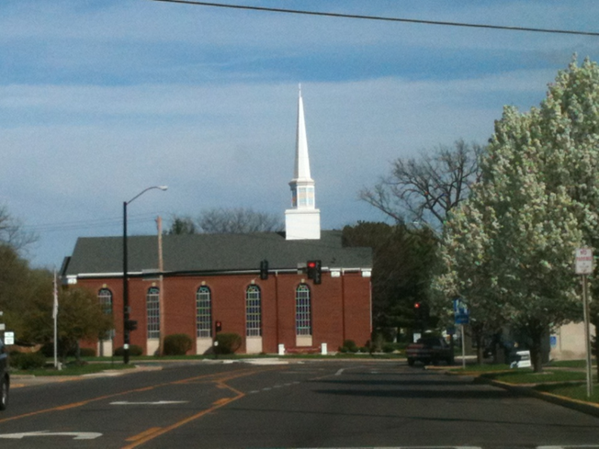

3. The sanctuary comfortably seats approximately 200.

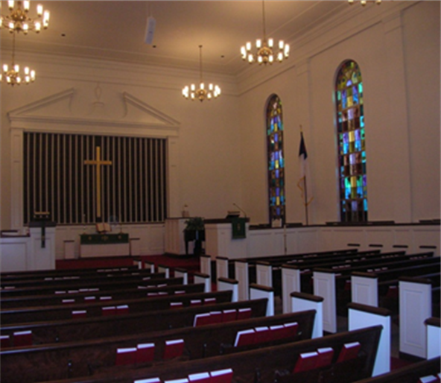

4. Our church is a one-story brick building with a sanctuary, office for the pastor, secretary’s office, nursery, choir room, Morgan Hall (large fellowship room), kitchen, lounge, restrooms and two Sunday school rooms. There are also two large rooms in the basement. The church grounds include a large lawn, playground, Memorial Brick garden, parking, fire pit and room for expansion.

5. Our well-maintained parsonage is a two-story brick home, which was built in 1928. It has four bedrooms and full bath upstairs, kitchen and appliances, dining room, living room, office, ½ bath downstairs and full basement. There is also a 3-season room and a one-car garage.

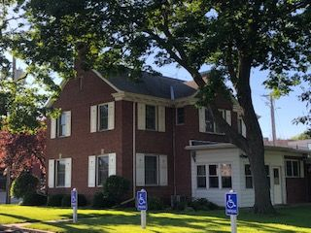
COMMUNITY INFORMATION

1. Peru is a town with a population of 10,300. Centrally located in the Illinois Valley, Peru is within a 70- mile radius of Rockford, Bloomington-Normal, Rock Island-Moline and Peoria and within 100 miles of Chicago. Peru is part of a quad-city area that includes Peru, La Salle, Oglesby and Spring Valley with a combined population of around 30,000. Peru’s website www.peru.il.us

2. Other denominations in the community include Catholic, which is dominant, Methodist, Lutheran, Baptist, UCC, Pentecostal, Jehovah’s Witness, and Episcopal.

3. The following community groups currently meet in the church: Cub Scouts of which we are the charter church, Girl Scouts, and the Pink Ribbon Club. In addition, the church hosts musical recitals, fundraisers and workshops.

4. We seek to work with other congregations in areas of mutual interest and concern.

5. Excellence in education is a tradition in the Illinois Valley. Peru has an excellent public school system. There are also several private schools in the area. The majority of high school students continue to some form of higher education, many attending Illinois Valley Community College.

6. Illinois Valley Community College, Northern Illinois University, Illinois State University, Bradley University and other junior colleges are within easy commuting distance.

7. Some of the important employers in the area are American Nickeloid, St. Margaret’s Hospital Spring Valley, St. Margaret’s Hospital Peru, Eakas, Maze Nail, Carus Chemical, James Hardie, Illinois Cement, Unityte, Wal-Mart Distribution Center, Illinois Valley Community College and considerable agricultural ventures in the surrounding area.

8. Factors that make our community desirable include a small-town atmosphere, Midwestern values, the Illinois River and the water activities it provides, five state parks within a short distance covering over 2000 wooded acres. The junction of I-39 and I-80 make travel very convenient. Major cities are easily reached in every direction by interstate and by local Amtrak stations in Mendota and Princeton. There is a variety of shopping opportunities locally along with a large selection of fine dining choices. The Illinois Valley YMCA has one of the largest aquatic centers in Illinois and much more to offer. For more information about our community, contact the Illinois Valley Chamber of Commerce - www.ivaced.org

CHURCH FINANCES

1. Our budget is underwritten by member giving, fundraising events, minimal interest from investments, and rental payments from St. Margaret’s Hospital Peru for their use of our parking lot.

2. Special offerings the church has throughout the year:
Easter
Thanksgiving
Christmas

3. Missions, ministries and agencies that are financially supported by the church: supplies are collected and given to PADS (our local homeless shelter) and local food pantries: gifts are donated by our congregation to Nursing Home residents at Christmas; caps and scarves are donated and given to local schools for at-need students. We support the following missionaries: Jane & Ed Skowren of New Tribes Missions, Pastor Roy Jacob of Peace Mission in India; Pastor Chris and Christina Surber with Supply and Multiply; Abigail Women’s Center, Bible Tracks, transport for Christ, a local Christian Radio station Z90.7 and Jews for Jesus.

4. Expenses for the past 3 years

 | 2018 | 2019 | 2020
Budget | $167,037.00 | $158,186.00 | $159,719.00
Actual | $160,440.69 | $159,730.23 | $138,092.11
Missions | $4000.00 | $3000.00 | $4000.00

5. Paid positions in the church:
Full-time: Pastor
Part-time: Church Secretary
Church Treasurer
Organist
Financial Secretary

